10th June 2026
Step1:
Stopping the Mongodb Connection
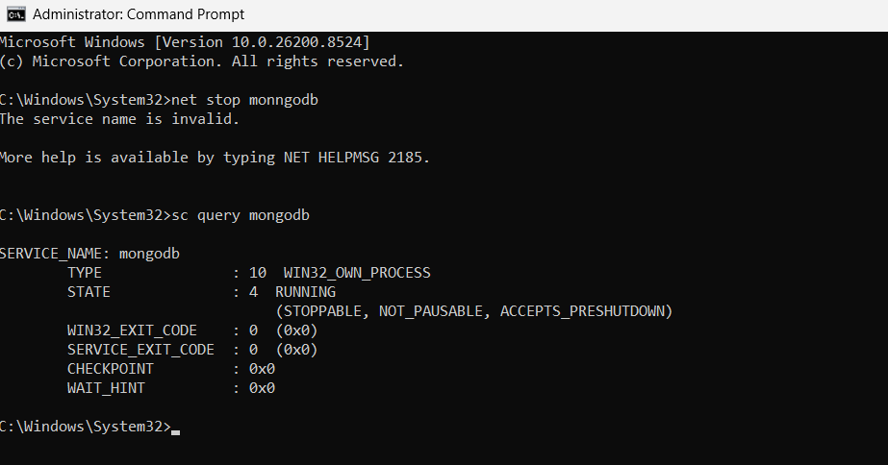

Step 2:
Creating 3 different files

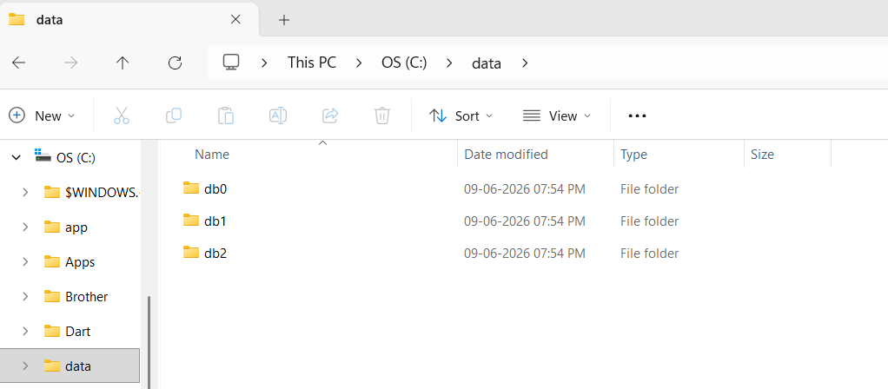

Step 3:
Instance for db0

C:\Program Files\MongoDB\Server\8.3\bin\mongod.exe" --replSet myReplSet --dbpath C:\data\db0 --port 27017 --bind_ip localhost

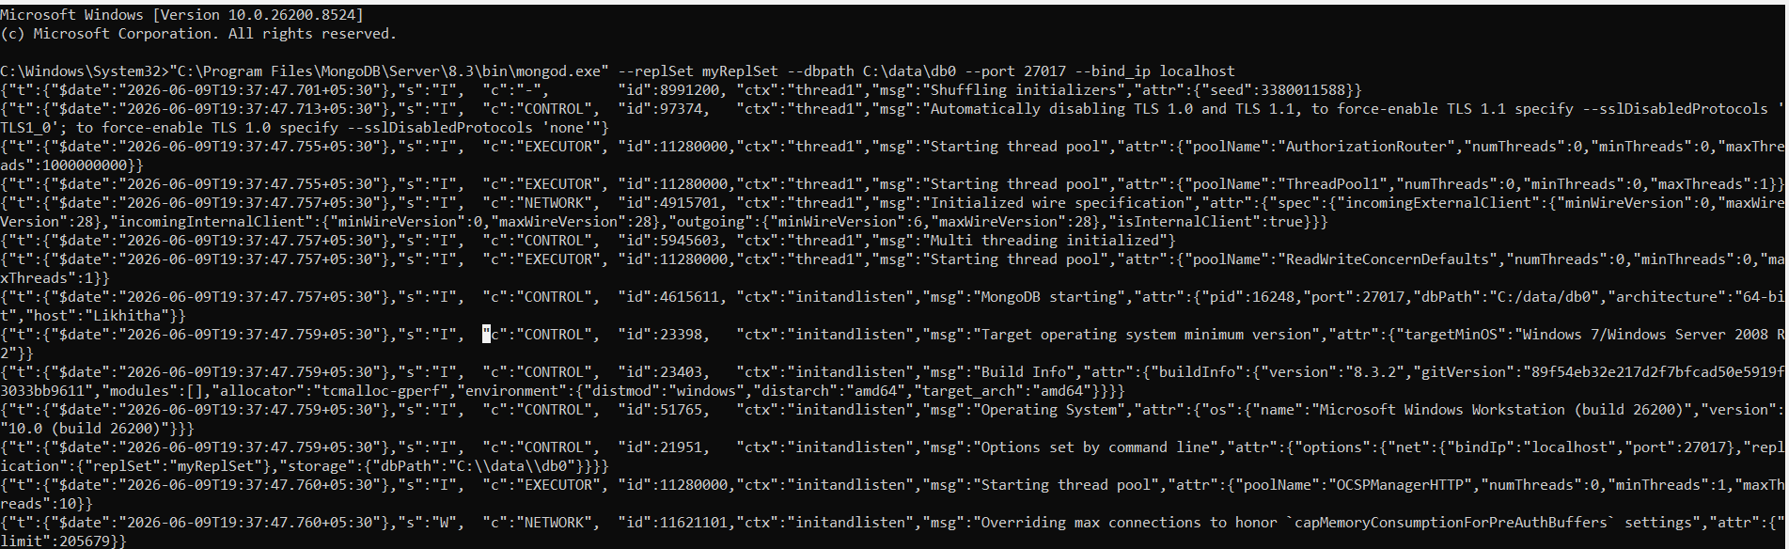

Instance for db1

C:\Program Files\MongoDB\Server\8.3\bin\mongod.exe" --replSet myReplSet --dbpath C:\data\db1 --port 27018 --bind_ip localhost

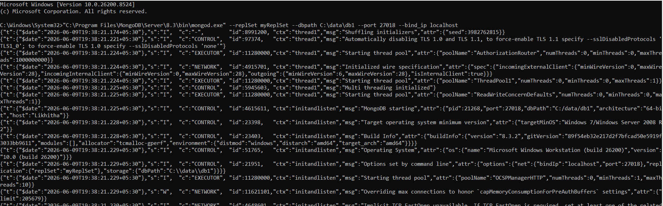

Instance for db2

C:\Program Files\MongoDB\Server\8.3\bin\mongod.exe" --replSet myReplSet --dbpath C:\data\db2 --port 27017 --bind_ip localhost
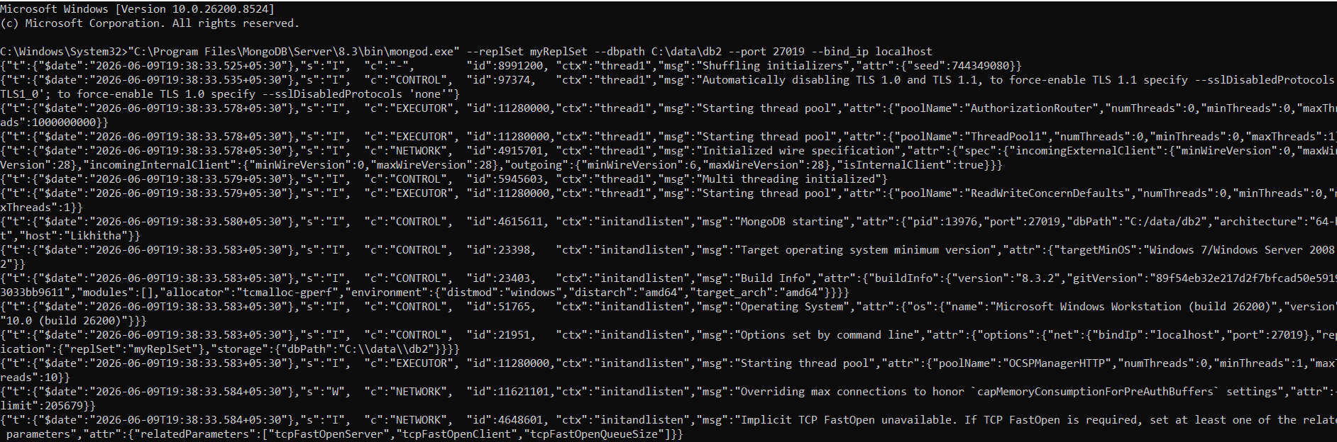

Step 4:
Mongodb connection
mongodb://127.0.0.1:27017/?directConnection=true
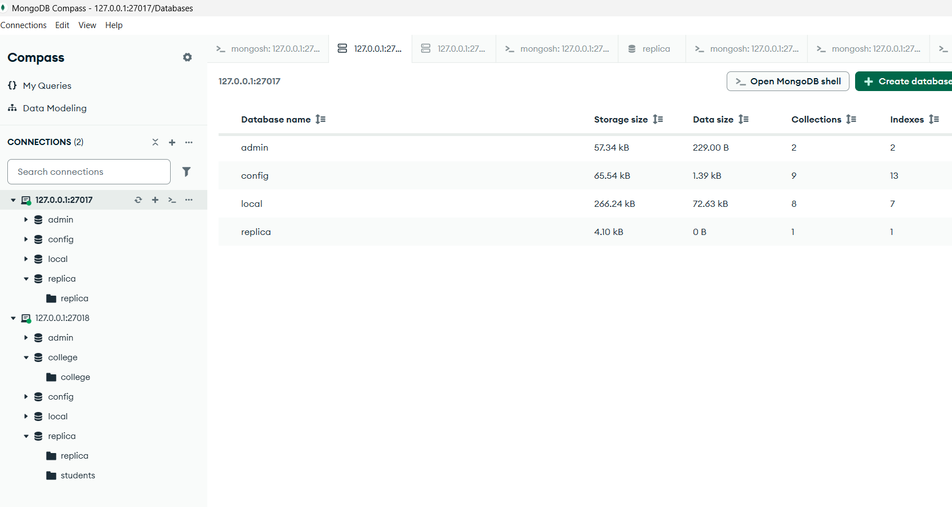

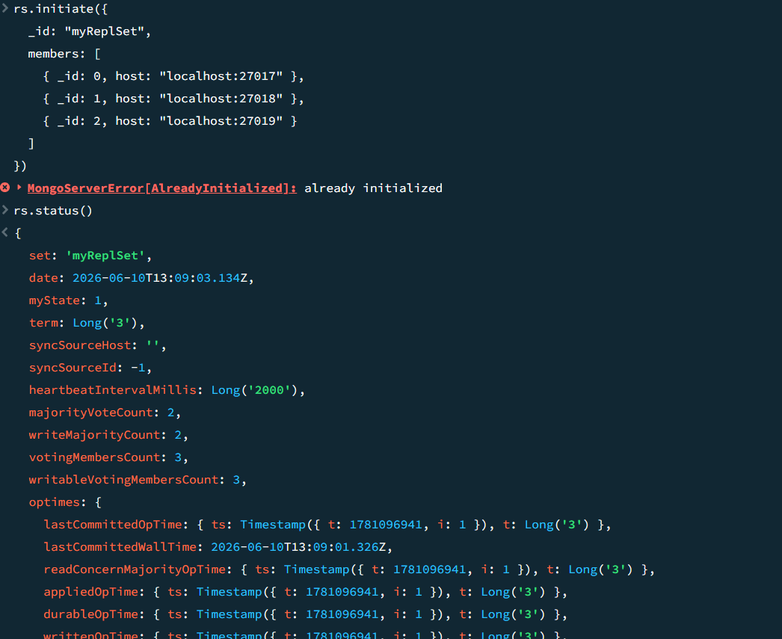

db0 becomes primary
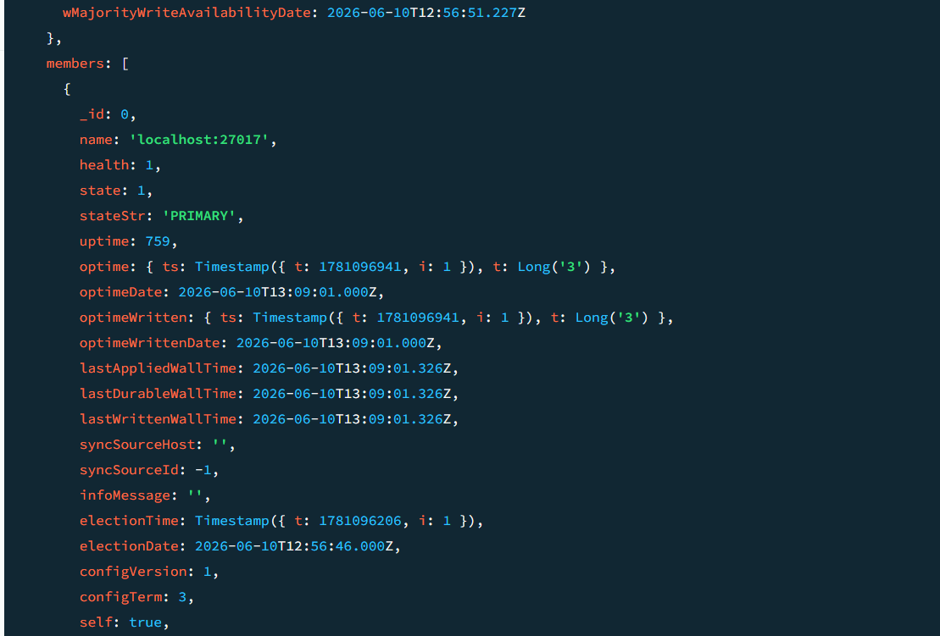

db1 becomes Secondary
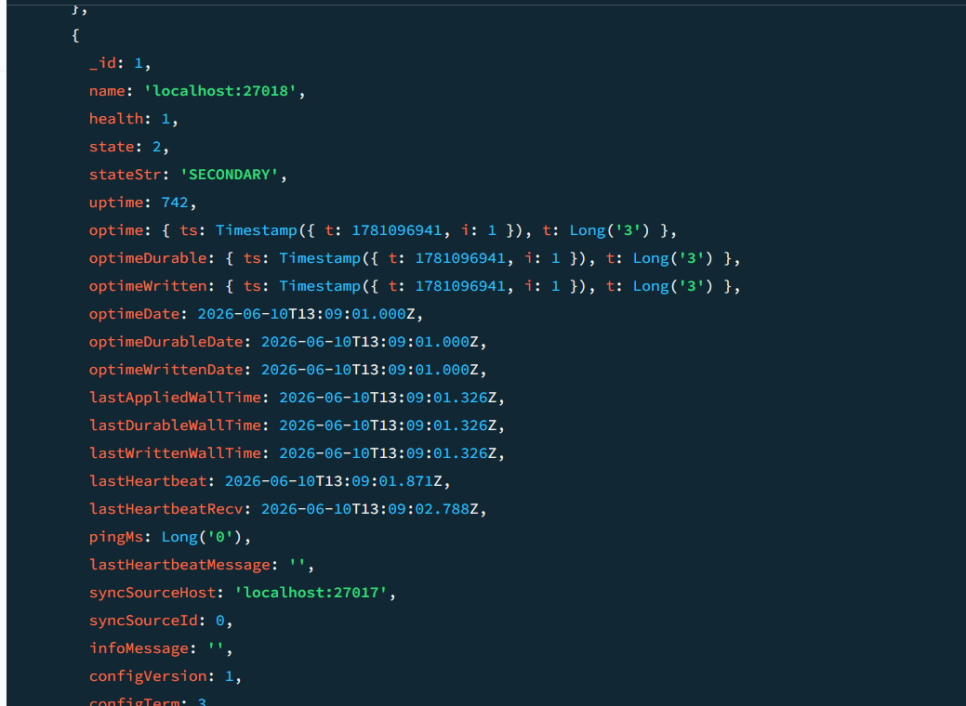

Step 5:
Creating a database named replica
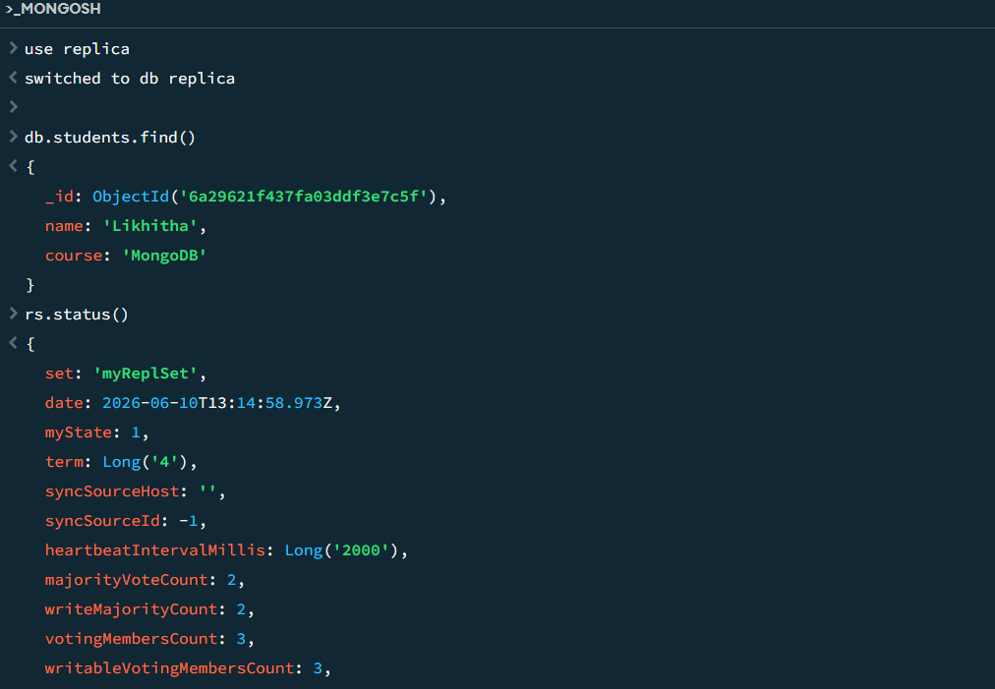
Step 6:
After changing the primary to secondary
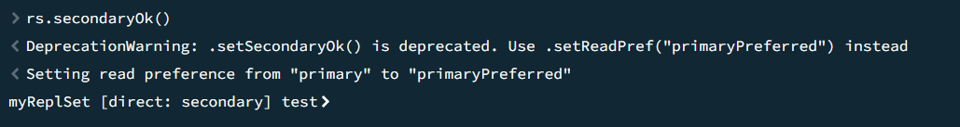
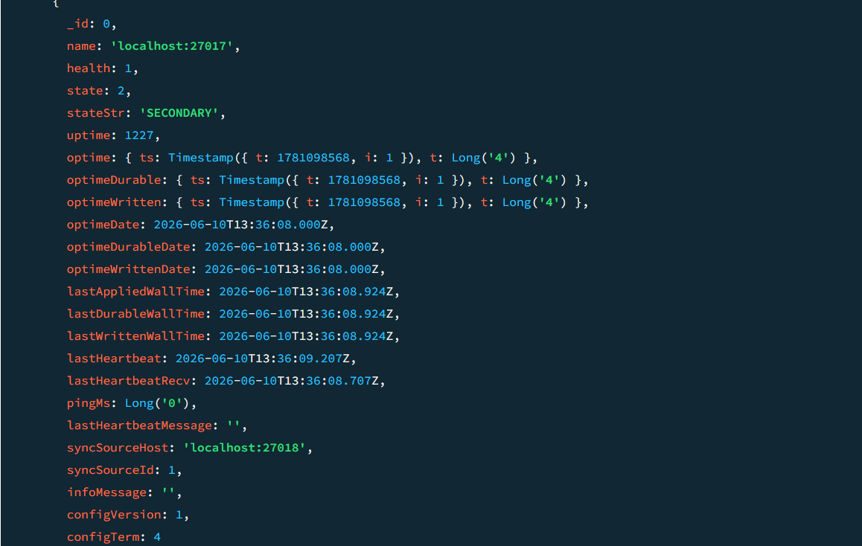
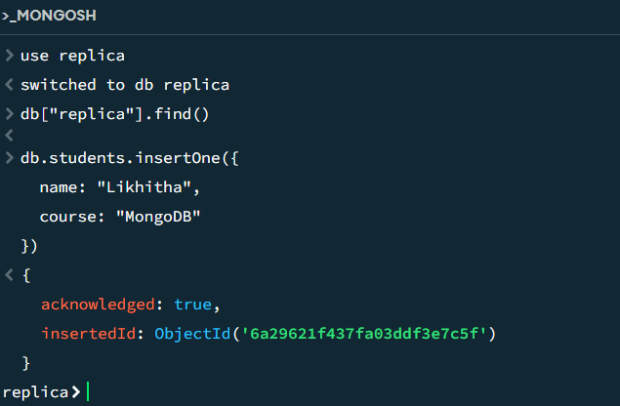

Step 7:
Starting the Mongodb
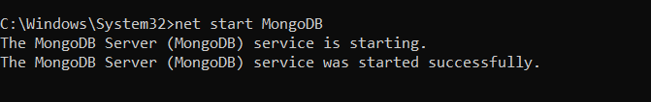

Sharding
Step 1:
Creating 2 folders in data

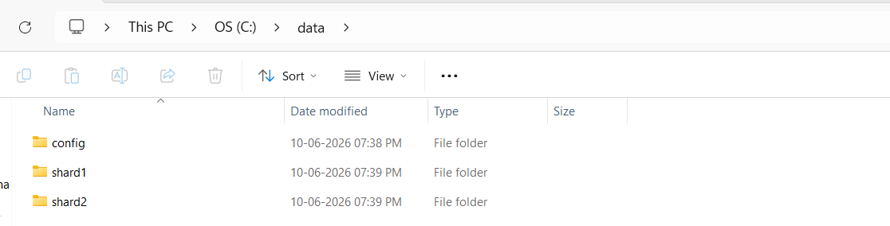

Step 2:

